**Chapter 4: DC Biasing – BJTs**

Table of Contents

4.1 Introduction 2

4.2 Operating Point 3

4.3 Fixed-Bias Configuration 4

4.4 Emitter-Bias Configuration 8

4.5 Voltage Divider Bias Circuit 10

## 4.1 Introduction

For the configurations we will be looking at in this chapter, remember that $V_{BE}=0.7V$, $I_{C}=βI_{B}$ and $I_{E}=I_{C}+I_{B}=\left(β+1\right)I_{B}≈I_{C}$

## 4.2 Operating Point

The term biasing is an all-inclusive term for the application of DC voltages to establish a fixed level of current and voltage. For transistor amplifiers, the resulting DC current and voltage establish an operating point on the characteristics that defines the region that will be used to amplify the applied signal.

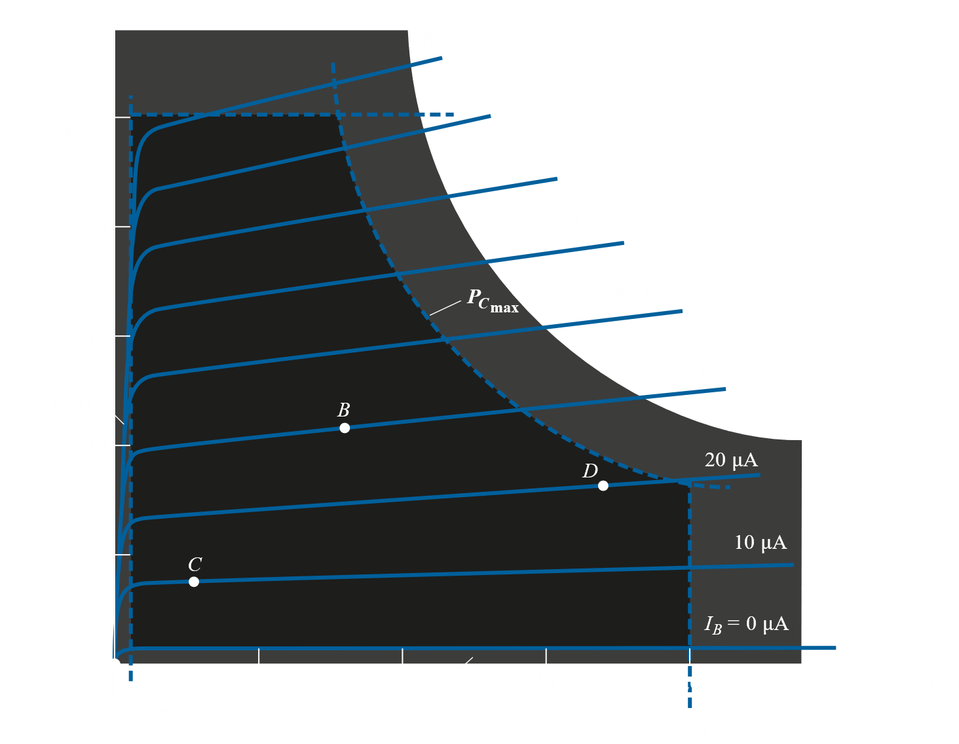

Biasing circuits can be chosen to set the device operation at any of the points within the active region. We can also set it up to operate outside this region, but that will likely shorten the life of the device or destroy it.

In general, it is a good idea to chose an operating point well inside the active region. Too far to the sides will result in the final AC signal, which will move the point a little here and there, to fall into the saturation or cut-off regions. It is also smart to operate where the gain is more or less constant, so that amplification is the same for the entire signal.

We should also consider the change in the operating point due to changes in temperature. The maintenance of the operating point is specified by a stability factor $S$. We will be looking into this for the different circuits.

## 4.3 Fixed-Bias Configuration

The fixed-bias circuit is the simplest transistor DC bias configuration. This is what it looks like:



It is a common emitter configuration, as will be made clear soon. This circuit is used for amplification purposes, with the extra energy required for amplification coming from $V_{CC}$. The capacitors given in series with the AC input and output signals allow AC signals to pass, but not DC signals. Thus, for the DC equivalent circuits, the capacitors are replaced with open-circuit equivalents.

We can create the DC equivalent circuit like this:



Separating the $V_{CC}$ into two parts makes no difference, but it does make it easier to visualize the two separate loops. First, the Base-Emitter loop.



This is the input side. From KVL, $V_{CC}-I_{B}R_{B}-V_{BE}=0$. Thus, $I_{B}=\frac{V_{CC}-V_{BE}}{R_{B}}$. We can set the input current $I_{B}$ by simply changing $R_{B}$.

Next the Collector-Emitter loop.



This is the output side. Again, following KVL, $V_{CC}-I_{C}R_{C}-V_{CE}=0$

We can now draw the output characteristics curve.



At $V_{CE}=0$, $I_{C}=\frac{V_{CC}}{R_{C}}$ and at $I_{C}=0$, $V_{CE}=V_{CC}$. This gives us the load line. The intersections are the operating points for the different values of $I_{B}$.

Example 4.1



The operating point value for $I_{B}$ is $I_{BQ}=\frac{12-0.7}{240}=47.08μA$

The operating point value for $I_{C}$ is $I_{CQ}=βI_{BQ}=50×47.08=2.35mA$

The operating point value for $V_{CE}$ is $V_{CE_{Q}}=V_{CC}-I_{C}R_{C}=12-\left(2.35\right)\left(2.2\right)=6.83V$

If we find that our operating point has gone too close to the saturation point, we can do a number of things. Changing $R_{C}$ or $V_{CC}$ will allow us to move the operating point along the same $I_{B}$ line. Changing $I_{B}$ will move the operating point vertically.

## 4.4 Emitter-Bias Configuration

This is almost exactly the same as the Fixed-Bias Circuit, except that it has an additional resistor $R_{E}$ on the emitter side.



This change makes the configuration more stable, meaning its response will change less due to undesirable changes in temperatures and parameter variations.

Making the same observations for this circuit as we did for the Fixed-Bias configuration, the DC equivalent looks like this:



The Base-Emitter loop looks like this:



So, we get $V_{CC}-I_{B}R_{B}-I_{E}R_{E}-V_{BE}=0$. We know that $I_{E}=\left(1+β\right)I_{B}$, so

$$I_{B}=\frac{V_{CC}-V_{CE}}{R_{B}+\left(1+β\right)R_{E}}$$

The Collector-Emitter loop looks like this:



$V_{CC}-I_{C}R_{C}-I_{E}R_{E}-V_{CE}=0$ and since $I_{E}≈I_{C}$, $V_{CC}-I_{C}\left(R_{C}+R_{E}\right)-V_{CE}=0$.

We can now draw the output characteristics curve.



## 4.5 Voltage Divider Bias Circuit

The previous bias configurations had bias current $I_{C_{Q}}$ and voltage $V_{CE_{Q}}$ dependent on the current gain $β$ of the transistor. The value of $β$ is temperature sensitive, so it would be desirable to develop a bias circuit that is independent of $β$.

This is the circuit for a voltage divider bias configuration:



We will be looking at the exact analysis method (as opposed to the approximate analysis method). The DC equivalent for the above circuit is this:



Which leads us to redraw the input side like this:



To make things even simpler, we can replace this circuit with the Thevenin’s equivalent, where $R_{Th}=R_{1}||R_{2}$ and $E_{Th}=\frac{R_{2}V_{CC}}{R_{1}+R_{2}}$

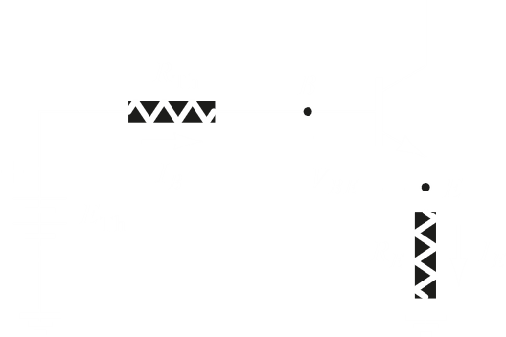

Thus, we get,

$$I_{B}=\frac{E_{Th}-V_{BE}}{R_{Th}+\left(β+1\right)R_{E}}$$

From the collector side we obtain,

$$V_{CE}-V_{CC}-I_{C}\left(R_{C}+R_{E}\right)=0$$

From these equations, we can form the load line analysis.